EL LUGAR MÁS PEQUEÑO
The Tiniest Place

Ópera prima CCC
Directed by Tatiana Huezo

CONTACTS:
Centro de Capacitación Cinematográfica
divulgacion@elccc.com.mx
52.55.4155.0090 ext. 1813, 1805
www.elccc.com.mx

Tatiana Huezo
tathuezo@yahoo.com

Mexico, 2011 / 35 mm, Color / Documentary, 108 min.
EL LUGAR MÁS PEQUEÑO / THE TINIEST PLACE
Mexico, 2011
35 mm, Color
Documentary, 104 min.
Dirección / Director: Tatiana Huezo Sánchez
Producción / Producer: Nicolás Celis
Guión / Script: Tatiana Huezo Sánchez
Fotografía / Cinematography: Ernesto Pardo
Edición / Editing: Paulina Del Paso, Tatiana Huezo Sánchez, Lucrecia Gutiérrez.
Sonido / Sound: Federico González
Diseño Sonoro / Diseño Sonoro: Lena Esquenazi
Música original / Original music: Leonardo Heiblum y Jacobo Lieberman
Compañía productora / Production Company: Centro de Capacitación Cinematográfica, FOPROCINE (Fondo para la Producción Cinematográfico de Calidad) con el apoyo / with the support of BECA GUCCI-AMBULANTE.

Locación / Location: Cinquera, Departamento De Cabañas. El Salvador, C.A.
Filmado en / Shooting format: Full HD
Aspect ratio / Mascarilla de proyección: 1.1:85
Sonido / Sound: Dobly Digital
Pietaje / Footage: 6120 ft / 1865.4 mt. / 24 fps

SINOPSIS:

This is a story about man kind’s ability to arise, to rebuild and reinvent himself after surviving a tragedy. A story about a people that have learned to live with their sorrow; an annihilated town that re-emerges through the strength and deep love of its’ inhabitants for the land and the people. A tiny place nestled in the mountains amidst the humid Salvadorean jungle.
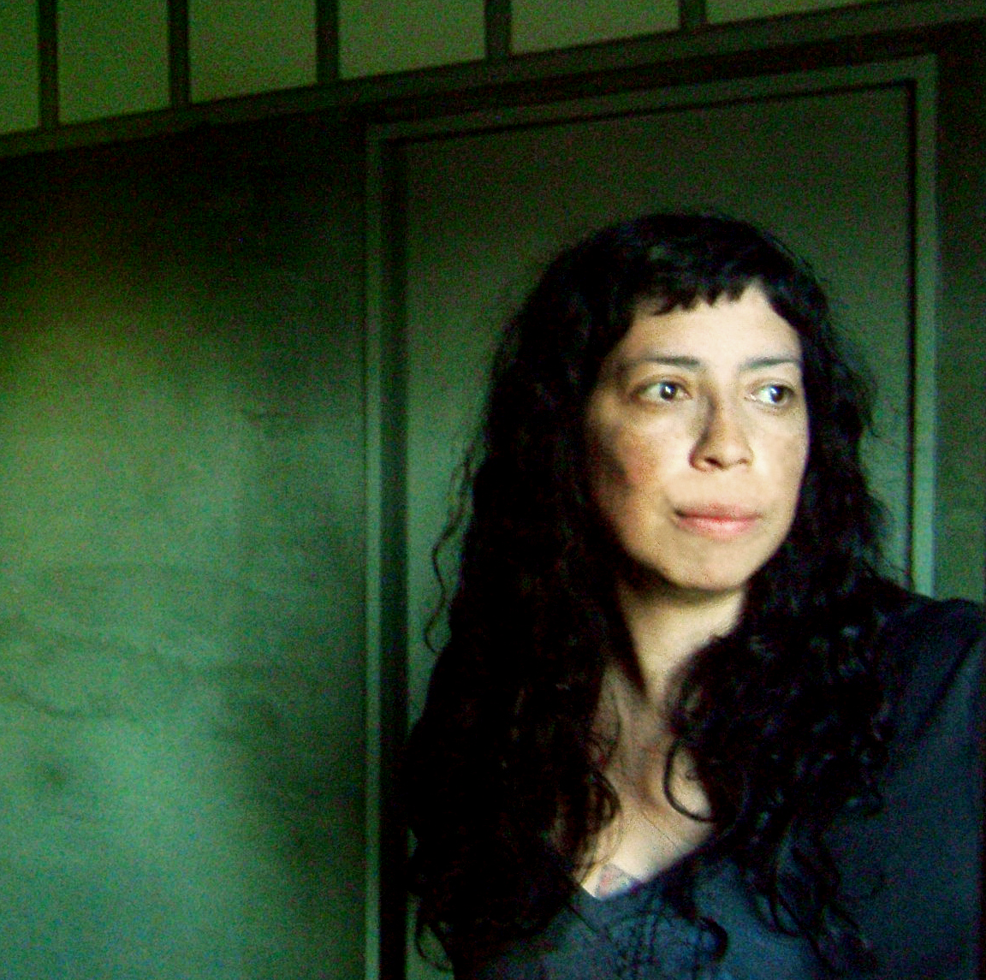
TATIANA HUEZO. DIRECTOR.
Tatiana Huezo Sánchez was born January 9th, 1972 in San Salvador, when she was four years old she moved to Mexico City where she lived and studied.
She is a director and cinematographer. She is a graduate of the Centro de Capacitación Cinematográfica. She has directed several short fims and documentaries.
She received a grant from the National Culture and Arts Fund to produce the documentary: FAMILY PORTRAIT and a grant to study a master’s degree in Documentary Filmmaking at the University of Pompeu Fabra in Barcelona, Spain from 2004-2006. THE TINIEST PLACE is her opera prima.

Filmography:
Retrato de Familia / Family Portait (2008, Betacam, Color, 45 min., Doc., Director and editor)
El ombligo del Mundo / The Coreo of the Earth (2001, 35mm, Color, 30 min. Fic., Director and Cinematography)
Tiempo Caústico / Caustic Time (1998, Betacam, Color, Fic., Director and Script)

DIRECTOR’S TEXT

I was born in El Salvador, my father is Salvadorean and he and all his family lived through the civil war (1979-1992), I did not. One year before the war broke out, I moved to Mexico with my mother, I was four years old. My mother is Mexican and I grew up in Mexico.

I always travelled back to El Salvador. A few years ago I visited my paternal grandmother in San Salvador and she took me to the town were she was born, Cinquera. It took us three hours to get there on dirt roads. That same evening we arrrived I went out for a walk, alone. Suddenly an eldery woman hugged me, “Rina!” she shouted “you came back! You haven’t changed a bit!”. I didn’t know how to react, I told her it was a mistake, that I wasn’t Rina. The woman didn’t believe me. I’m not Rina, but I could have been.

Later, I stepped into the small town church, the walls were filled with bullet holes, there were only a few wooden benches, a military helicopter tail hung on a wall. There were very few religious images on the walls but there were rows of portraits of young people that died in the war.
The images and sensations of this space touched me deeply. I felt a need to know everything that happened here.

These first moments in my grandmother’s town motivated me to make this film.

HOW THE STORY IS TOLD.
I decided not to videotape the interviews, I only taped audio, I wanted to explore a different way of sharing this story.

The conversations with the people became deeper, more intimate and reflexive, this was the tone I wanted for this film.

I knew just how I wanted to tell the story, I wanted the imagen and the sound to develop independently and bring them together in a tirad discourse.

It was very exciting to edit the film, to discover and search for the meaning in the images, as the dialogue was knitted through them.

PRODUCTION NOTES.

One of the challenges of this film was to register the jungle that surrounds this town. We were a small crew of seven persons that travelled from Mexico to Cinquera. When we went up the mountain, Nico, the producer contacted the townspeople to help us carry water, food and all the production equipment. We walked for hours and hours everyday. Sometimes we got up at 3 amin order to reach a hill to shoot the daybreak. We had an incredible guide who had been in the guerrilla, René. One day we got lost in the darkness in midst of the mountains, we got stuck, René was desperate trying to clear the way with his machete, he looked up at the stars and spoke to himself trying to lead us to the shooting site. We didn’t make reach the point on time and the sun rose before we began the shoot.
The production lasted nearly 9 weeks under a humidity of 80% and hot weather. Spending time in the town was important, we had to build a relationship with the people in order to gain their trust.

The whole crew enjoyed the experience and we all learned from these townspeople that let us enter their lives with an open heart.

This is my first feature project and the first Documentary Opera Prima film produced by the CCC. I planned this documentary about five years ago. I tried to get financing, I am not very good at this, finding support for documentary projects is even harder. I had abandoned the Project and then the CCC opened a contest for it’s graduates. I sent in my project, I made a call to the town to find out if my contacts around and let them know I would try to make the film. My project was selected.

I am truly fortunate to have the best producers for this project, I was allowed complete creative freedom. I was amble to make the movie I had planned to. The school accept the long shooting period I requested.

I would like people to feel identified with the film; to provoke a reflexion on the traces that violence leaves on humans.

I wasn’t a guerrilla and I did not flee from an army that killed my family and destroyed my town. This is story told from my ignorance of what it means to live a war.

I believe the film is a miror were one can be reflected, in the pain, love and madness of the character. We know who they are and what they have lost, dignified in their pain, proud of were they are, knowing that laughter helps heal the soul.

FESTIVALES Y PREMIOS / FESTIVALS AND AWARDS

-Festival Ambulante, Feb. 2011 México

-Visions du Reel, Nyon Suiza, Abril 2011 Grand Prix La Poste Suisse, Mejor largometraje / Best Feature Film

* Premio del Jurado Interreligioso / Jurie´s Award (SIGNIS), Mejor largometraje / Best Feature Film.
- Festival Internacional de Cine en Guadalajara, Mar. 2011
-San Francisco Film Festival, Apr.2011
-Documenta Madrid May 2011 PREMIO DEL PÚBLICO / AUDIENCE AWARD
- Los Angeles Film Festival, International Spotlight on the Ambulante Film Festival, Jun 2011.
- Distrital, México DF Jun. 2011
-33rd Moscow International Film Festival, Jun 2011

CONTACTS:
Centro de Capacitación Cinematográfica
divulgacion@elccc.com.mx
52.55.4155.0090 ext. 1813, 1805
www.elccc.com.mx

Director:
Tatiana Huezo
tathuezo@yahoo.com

